New Patient History Date:

Full Name_________________________________________________________ Phone____________________________ DOB:_________________

Address:______________________________________________________________________________ E-mail________________________________________________

Marital Status: M S W D Children? (#, ages)______________________________________________ SSN:____________________________
Occupation:__________________________________________ Employer:_______________________________
Are you: Right Handed Left Handed Ambidextrous

How did you find us? Friend/Family Internet Doctor Employer Attorney Other:______________________
How is most of your day spent? Standing Sitting Walking Lifting/Carrying
Have you ever been to a chiropractor? No Yes When/Why?______________________________________________________________
Ever had a vehicle crash injury? No Yes When?_____________________________________________________________________
Ever had a work-related injury? No Yes When?_____________________________________________________________________

Current Complaints or Issues that Brought You Here:
Describe each complaint/issue. When did it begin? How long have you had it?
________________________________________________________________________________________________________________________________________________________________________________________________________________________________________________________________________________________________________________________________________________________________________________________________________________________________________________________________________________________________________________________________________________________________________________________________________________________________________________________________________________________________________________________________________________________________________________________________

Have you had MRI, CT, or X-Rays for this condition? No Yes When/Where?___________________________________________________

Have you seen any other healthcare providers (MD, DO, PT, etc) for this condition? No Yes
Please describe:_______________________________________________________________________________________________________________________________

Who is your Primary Care Physician?____________________________________________________________________
May we send a report to your PCP? Yes No

Is your condition: Improving Worsening The Same Does your pain wake you from sleep? No Yes
Are symptoms interfering with: Work Sleep Sports Home Other

Describe Each Problem Area Separately (e.g., “neck pain”, “shoulder”, “lower back”)

Problem Area #1:________________________________________________________________________________________________________________________________________

Are your symptoms?: Constant Off and On
Grade your pain from 0 (no pain) to 10 (worst imaginable): 0 1 2 3 4 5 6 7 8 9 10

What provokes or alleviates your symptoms?_____________________________________________________________________________________________

Problem Area #2:________________________________________________________________________________________________________________________________________

Are your symptoms?: Constant Off and On
Grade your pain from 0 (no pain) to 10 (worst imaginable): 0 1 2 3 4 5 6 7 8 9 10

What provokes or alleviates your symptoms?_____________________________________________________________________________________________

Problem Area #3:________________________________________________________________________________________________________________________________________

Are your symptoms?: Constant Off and On
Grade your pain from 0 (no pain) to 10 (worst imaginable): 0 1 2 3 4 5 6 7 8 9 10

What provokes or alleviates your symptoms?_____________________________________________________________________________________________

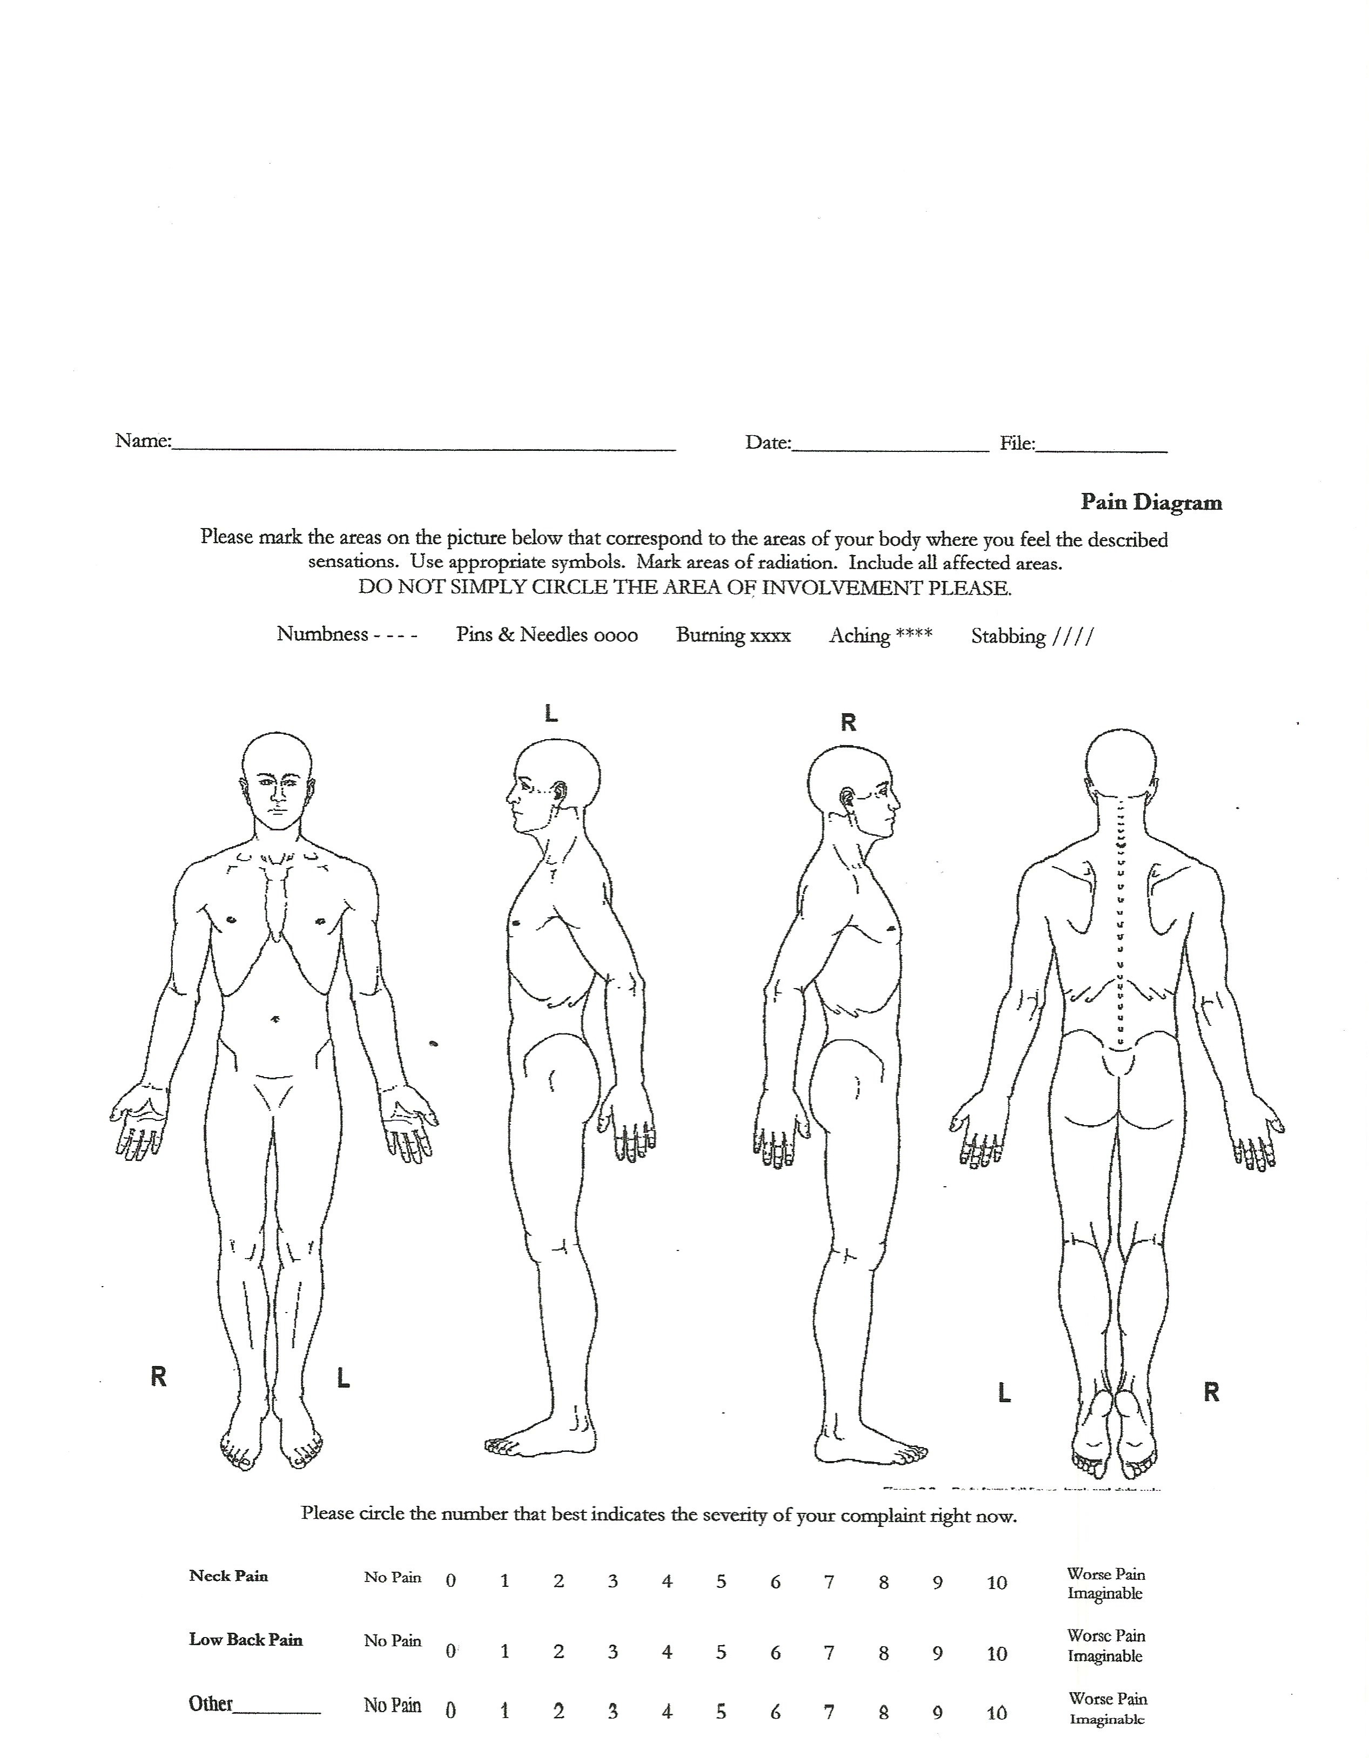

Past Medical History:

Please circle any of the following conditions if you are currently or have been previously diagnosed:

Back Pain | Concussion | Irritable Bowel | HIV + | Nervousness
Neck Pain | Knocked Unconscious | Digestion Problems | Hepatitis | Depression
Numbness/Tingling | Eye Injuries | Heart Problem | Mononucleosis | Anxiety
Sciatica | Sinus Problems | Kidney Problem | Anemia | Chemical Addiction
Jaw Pain/TMJ | Shortness of Breath | Thyroid Problem | Excessive Thirst | Eating Disorder
Headaches | Dizziness | Liver Problem | Night Sweats | Allergies
Shoulder Pain | Chest Pains | Gall Bladder Problem | Weight Loss | Difficulty Breathing
Elbow/Arm Pain | High Blood Pressure | Lung Disease | Frequent Urination | Asthma
Carpal Tunnel Syn. | Arteriosclerosis | Menstrual Irregularity | Diabetes | Chronic Cough
Knee Problems | Constipation | Menstrual cramps | Limb Edema | Cancer
Foot or Ankle Pain | Sleep Disorder | Prostate Problem | Bruise Easily | Lumps/Tumors
Wrist or Hand Pain | Fractures | Uterus/Ovary Problems | Chronic Fatigue | Bursitis
Sprained Ankle(s) | Osteoporosis (‘penia) | Skin Diseases | Lyme’s Disease | Other:

List ALL surgeries, major injuries, illnesses, or hospitalizations that you have had in the past. Do you have any residual issues?
________________________________________________________________________________________________________________________________________________________________________________________________________________________________________________________________________________________________________________________________________________________________________________________________________________________________________________________________________________________________________________________________________________________________________________________________________________________________________________

List ALL medicines, herbs/vitamins you currently take (attach or e-mail a list if you prefer):
________________________________________________________________________________________________________________________________________________________________________________________________________________________________________________________________________________________________________________________________________________________________________________________________________________________________________________________________________________________________________________________________________________________________________________________________________________________________________________

Family/Social History:
Do you smoke cigarettes? No Yes How much?
Do you drink alcohol Daily Socially Seldom Never
Please rate your daily stress level: 1 2 3 4 5 6 7 8 9 10

Describe your diet: ____________________________________________________________________________________________________________________________________________________________________________________________________________________________________________________________________________________________________________________________________________________________________________________________________________________________________________________________________________________

Describe your regular exercise program:
____________________________________________________________________________________________________________________________________________________________________________________________________________________________________________________________________________________________________________________________________________________________________________________________________________________________________________________________________________________

Any significant family history of: Diabetes Cancer Heart Disease
Conditions listed at top of page?:_______________________________________________________________________________________________

I certify that the above information is correct to the best of knowledge. I will not hold my doctor or any members of his/her staff responsible for any errors or omissions that I may have made in completion of this form.

_________________________________________________________________ ___________________________________________________________
Patient Signature Date

Financial Policy

Restoring your health is our foremost objective. Our treatment will always be rendered solely on the base of need. Please advise us if you are unable to fulfill this policy so that we may discuss and consider alternative payment options. We require payment at the time of service unless special arrangements have been previously made. Our fees comply with the usual and customary rates for this region. We accept checks, cash, or credit card payments.

REGARDING ALL INSURANCE: We cannot promise that an insurance company will pay for your care, even when it is preauthorized. We will submit bills to your insurance carrier, but will not become involved in disputes between the insured and the insurance company. This courtesy will commence as soon as we are able to confirm overage for chiropractic services and have the proper, signed insurance forms. Payment of non-covered and service balances, co-payments, and deductibles is expected at the time of services. We STRONGLY urge you to contact the insurance company to verify your benefits; sometimes incorrect information is provided to us.

If an insurance company fails to pay for services within 90 days, the undersigned is responsible for payment. Ultimately, you are responsible for outstanding balances. If the insurance company erroneously pays directly to the insured, the amount shall be forwarded to this office within 3 days.

MEDICARE: Medicare pays for only a portion of chiropractic services and limits the number of reimbursements treatments. Reimbursable care is limited to spinal manipulation and does not include other therapies, services, and goods that may be necessary during care. Please be advised of the following Medicare restrictions and regulations.
- Medicare will pay for a maximum number of treatments per calendar year, based on your diagnosis. When the maximum number of treatments has been rendered, payment is expected at the time of service.
- Medicare will NOT pay for an initial examination. This fee is the patient’s responsibility and will not apply to the patient’s deductible.

PERSONAL INJURY, WORKER’S COMPENSATION AND/OR LITIGATION: If your complaint is the result of an occupational or automobile accident, or if litigation is pending, please notify us. If an attorney is involved, patients are required to sign a Physician’s Lien that will be forwarded to the attorney for signature. If we do not receive the signed lien from the attorney within 14 days, all services must be paid for by the patient at the time rendered. It is our policy to bill the insurance company directly and will provide the attorney with a statement.

Instances will arise when we exhaust all reasonable efforts to secure payments through your insurance company, but the insurance company refuses payment. We will do our best to assist you in securing payments, but all balances are ultimately your responsibility.

MISSED APPOINTMENTS: There is a $75.00 charge for missed appointments without a 24-hour notice. This charge is the patient’s responsibility and cannot be billed by the insurance company. Missed appointments fees must be paid before scheduling subsequent appointments. We may request a deposit for future appointments. If more than three appointments are missed without notification, we will recommend you seek treatment at another facility, or schedule care when you are able to commit to the recommended treatment program.

In fairness to our patients who do pay for service, after reasonable efforts on our part to obtain payment, we will solicit the service of a collection agency if necessary.

I have read this financial policy and understand that I am financially responsible for all unpaid balances for my care.

Patient Signature: ____________________________________________________________ Date: _________________________

Our Privacy Pledge

We are very concerned with protecting your privacy. While the law requires us to give you a copy of this disclosure, please understand that we have, and always will, respect the privacy of your health information.

There are several circumstances in which we may have to use or disclose your health care information.

- We may have to disclose your health information to another health care provider or a hospital if it is necessary to refer you to them for the diagnosis, assessment, or treatment of your health condition.
- We may have to disclose your health information and billing records to another party if they are potentially responsible for the payment of your services.
- We may need to use your health information within our practice for quality control or other operational purposes.

We have a more complete notice that provides a detailed description of how your health information may be used or disclosed. You have the right to review that notice before you sign this consent form ( 164.520). We reserve the right to change our privacy practices as described in that notice. If we make a change to our privacy practices, we will notify you in writing when you come in for treatment or by mail. Please feel free to call us at any time for a copy of our privacy notices.

Your right to limited uses or disclosures

You have the right to request that we do not disclose your health information to specific individuals, companies, or organizations. If you would like to place any restrictions on the use or disclosure of your health information, please let us know in writing. We are not required to agree to your restrictions. However, if we agree with your restrictions, the restriction is binding on us.

Your right to revoke your authorization

You may revoke your consent to us at any time; however, your revocation must be in writing. We will not be able to honor your revocation request if we have already released your health information before we receive your request to revoke your authorization. If you are required to give your authorization as a condition of obtaining insurance, the insurance company may have a right to your health information if they decide to contest any of your claims.

I have read your consent policy and agree to it terms. I am also acknowledging that I have received a copy of this notice.

________________________________________________ ____________________________________________________
Patient Name Authorized Provider Representative

________________________________________________ ____________________________________________________
Signature Date

________________________________________________
Date

CHIROPRACTIC TREATMENT INFORMED CONSENT
The nature of the chiropractic manipulation: The primary treatment used by doctors of chiropractic is manual manipulation, also known as adjustment. I will use that and any other chiropractic procedures, including examination tests, diagnostic x-ray(s) and physical therapy techniques to treat the patient now and in the future. I will apply my hands to the area of your body to be treated in such a way as to move your joints. This may cause an audible “pop” or “click” similar to when you “crack” your knuckles. You may feel or sense movement.
The materials risks inherent in chiropractic adjustment: There are potential complications that may arise with any health care procedure. During manipulation, those complications include (but are not limited to); fractures, disc injuries, dislocations, muscle strain, Horner's syndrome, diaphragmatic paralysis, cervical myelopathy and costovertebral strains and/or separations. Some patients will feel stiffness and soreness following the first few days of treatment. Some techniques used to manipulate the cervical spine (neck region) have been implicated in injuries to arteries in the neck leading to, or contributing to, serious complications that include stroke. I have also indicated that with any procedure there is the possibility of an unexpected complication, though no guarantees or promises can be made concerning the results of any procedure or treatment.
The probability of those risks occurring: Fractures are rare occurrences and generally result from some underlying weakness of the bone. We screen for these risk factors during the history, examination and on x-rays (if x-rays are indicated). Manipulation induced stroke has been a subject of disagreement within and outside the profession. One prominent authority (Haldeman,DC,MD) states that there is, at most, a one-in-a-million chance of such an outcome. Since that risk should be avoided, we employ tests in our examination that are designed to identify whether you may be susceptible to such an injury. The other complications are also generally described as “rare”.
Treatment options other than chiropractic:
- Do nothing
- Self administered including over the counter analgesic and rest
- Medical care with prescription drugs such as anti-inflammatory, muscle relaxation and pain killers
- Surgery, Hospitalization, traction, rehabilitation
Risks inherent in other treatment options:
- The risk involved in doing nothing and remaining untreated. The formation of adhesions and loss of mobility sets up a pain pattern that may result in a chronic condition. Over time this may prolong treatment, make it more difficult and less effective.
- The risk in self administered treatment may result in overuse of over-the-counter medications which can produce undesirable side effects. If complete rest is impractical, premature return to work and other activities may aggravate the condition and extend the recovery time. The probability of such complications depends on the patient's general health, severity of discomfort, Pain tolerance and self-discipline.
- The risk involved with medical care and prescription drugs. Undesirable side effects and dependence on drugs. The risk also depends on the patient's general health, severity of discomfort, pain tolerance, self discipline and medical supervision. Medications generally entail significant risks, some with higher probabilities.
- The risk involved in surgery. Adverse reaction to anesthesia, iatrogenic (doctor caused) mishap, risk of hospitalization (exposure to communicable disease, iatrogenic mishap and expense), and an extended convalescent period. The probability of those risks occurring varies according to many factors.
DO NOT SIGN UNTIL YOU HAVE READ AND FULLY UNDERSTAND THE CHIROPRACTIC TREATMENT INFORMED CONSENT
Please check the appropriate block and sign below;
I have read [ ] or have had read to me [ ] the above explanation of the chiropractic adjustment and related treatment. I have discussed with Dr. Jean Kelly or Dr. Michael Melander and have had my questions answered to my satisfaction. By signing below I state that I have weighed the risks involved in undergoing chiropractic treatment and understand that there are other treatment options. By signing below I state I have myself decided that it is in my best interest to undergo the treatment recommended. Having been informed of the potential risks, I hereby give my consent to the aforementioned treatment.
Print Name:____________________________________ Date:_______________________________________________________
Signature:______________________________________ Signature of Parent/Guardian: __________________________

